**Lab 7A**

**Lab 7A - Code**

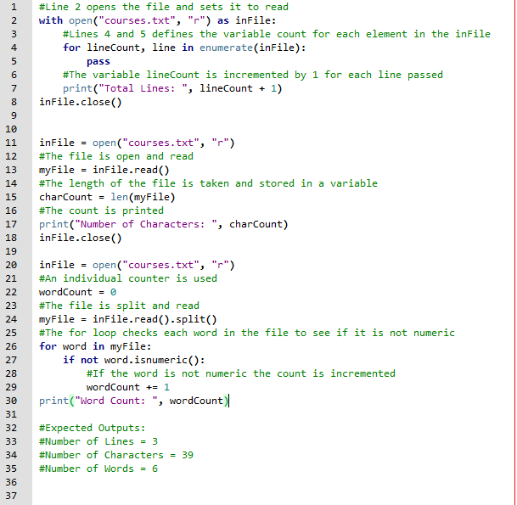

**Lab 7A - Console**

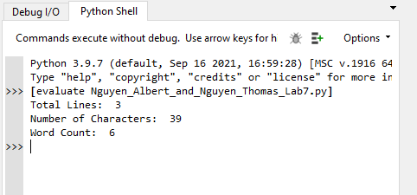

**Lab 7A - Output File**

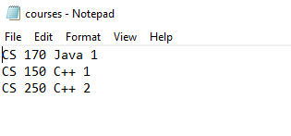

**Lab 7B**

**Lab 7B - Code**

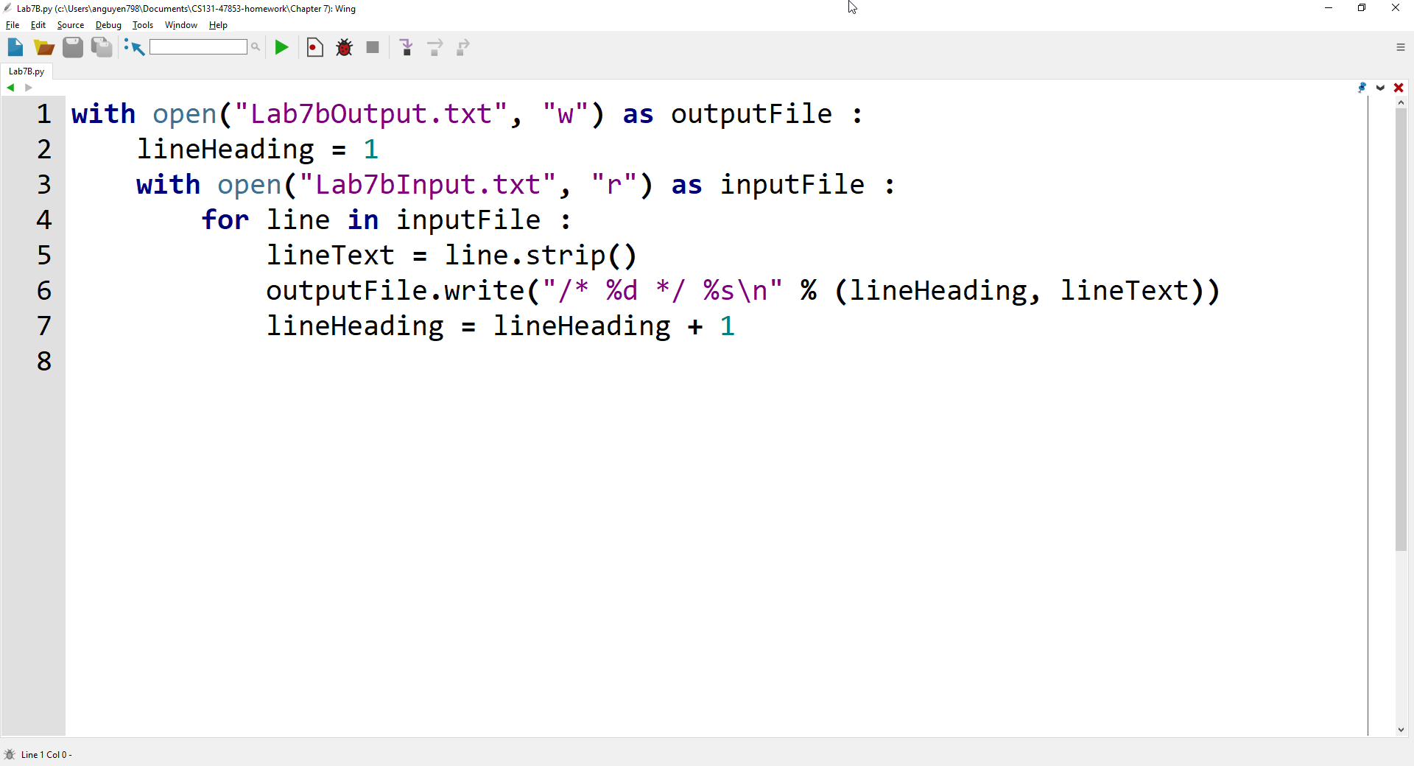

**Lab 7B - Output Files**

**Reading from Lab7bInput.txt**

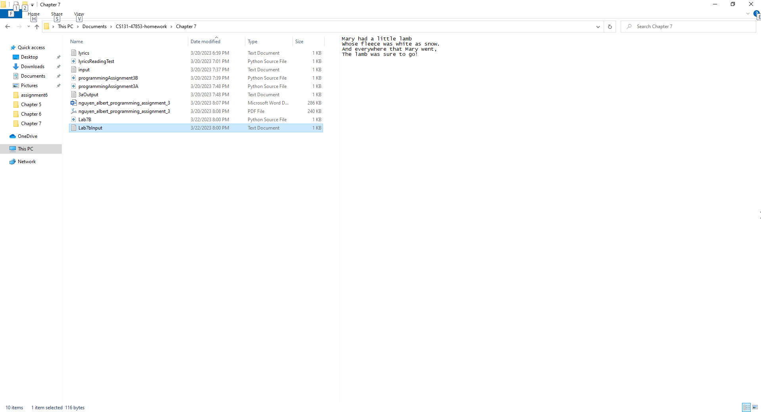

**Writing to Lab7bOutput.txt**

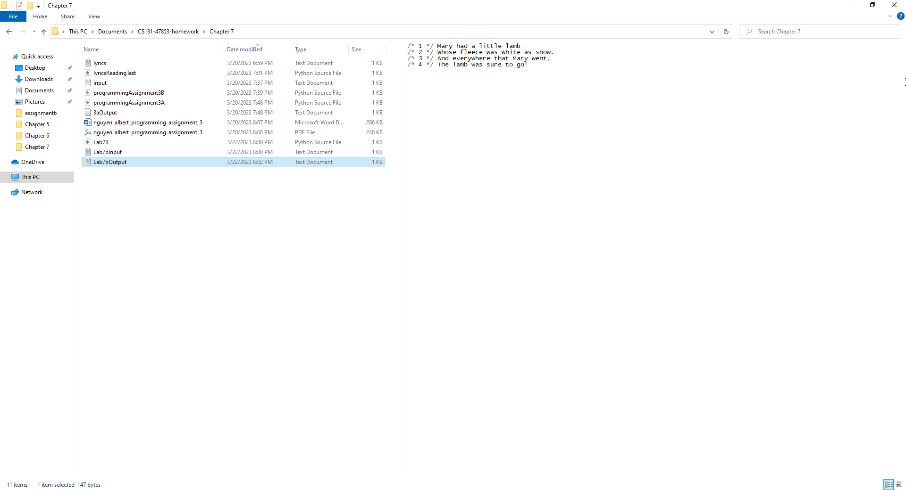

**Lab 7B - Console**

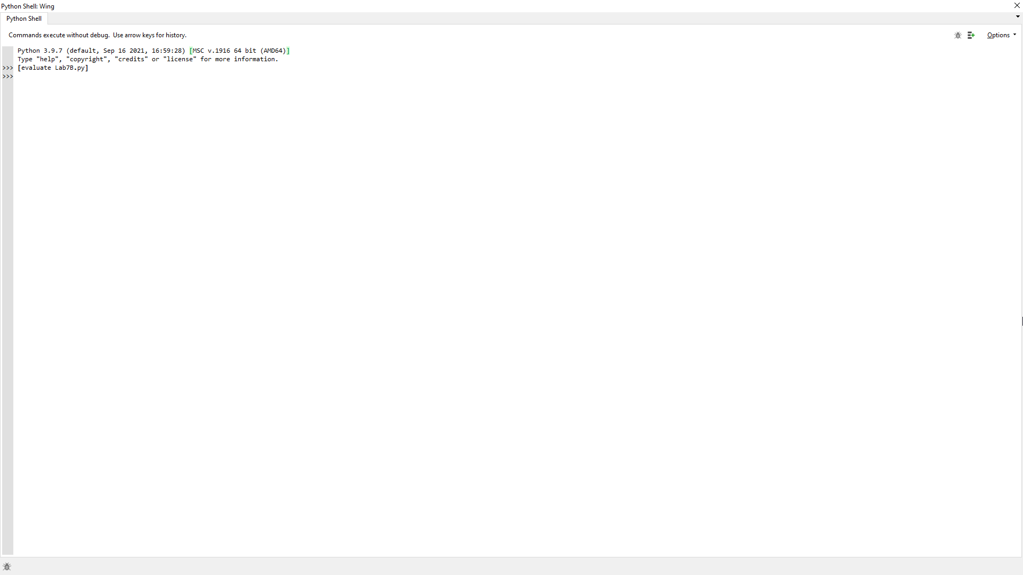

**Lab 7B - Written Code**

with open("Lab7bOutput.txt", "w") as outputFile :

    lineHeading = 1

    with open("Lab7bInput.txt", "r") as inputFile :

        for line in inputFile :

            lineText = line.strip()

            outputFile.write("/* %d */ %s\n" % (lineHeading, lineText))

            lineHeading = lineHeading + 1